**EXP 10)** Create a simple cloud software application for online super market using any Cloud Service Provider to demonstrate SaaS with the template of customer name, address, phone, email, items, quantity etc. with the item classification form

**PROCEDURE:**

**STEP 1:** GOTO ZOHO.COM

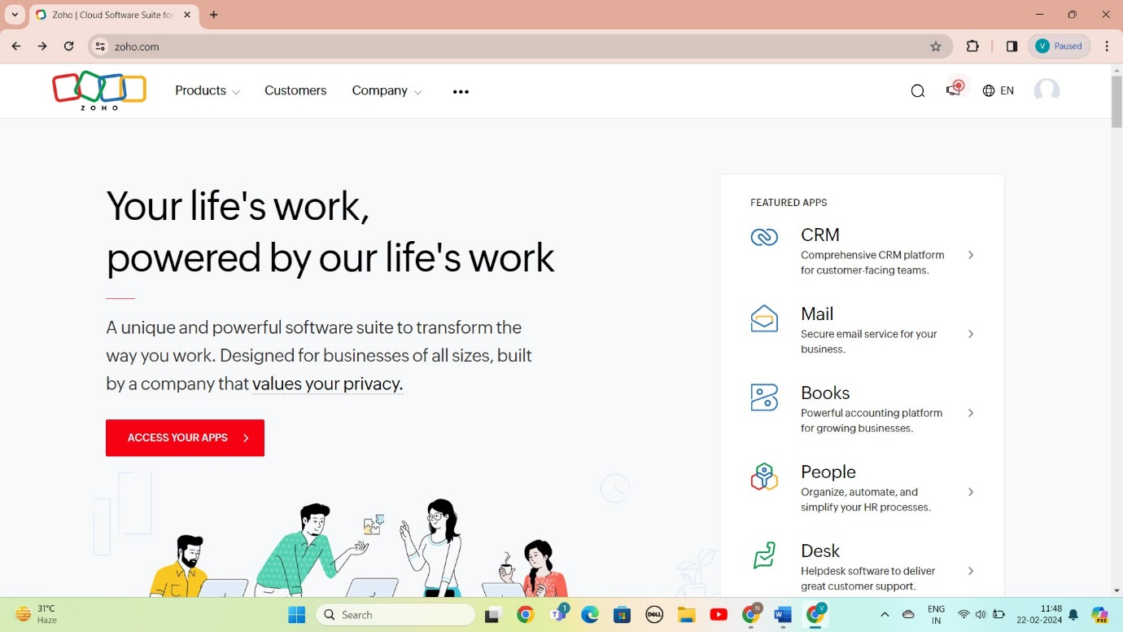

STEP 2: LOGIN TO THE ZOHO.COM

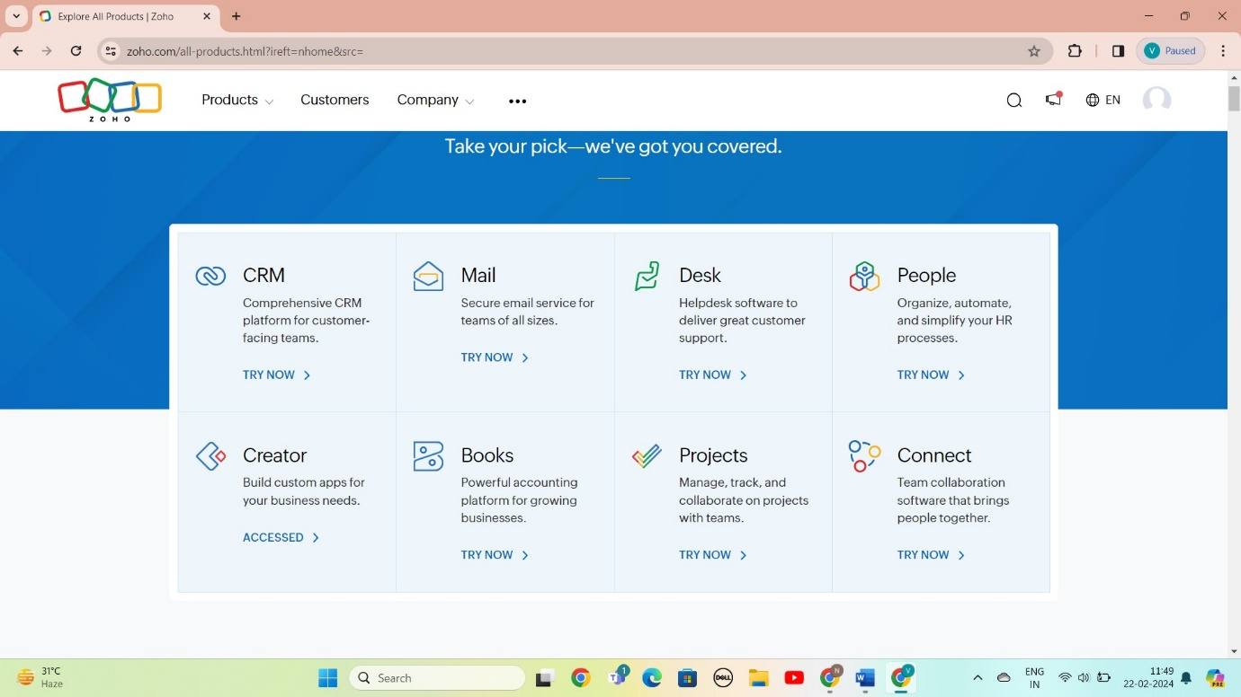

STEP 3: SELECT A CREATE FROM SCRATCH

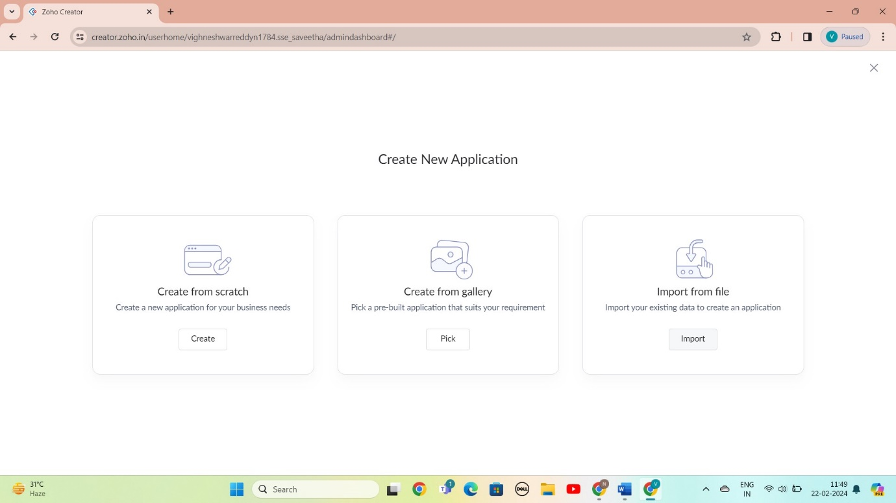

STEP 4: SELECT APPLICATION NAME AS online super market

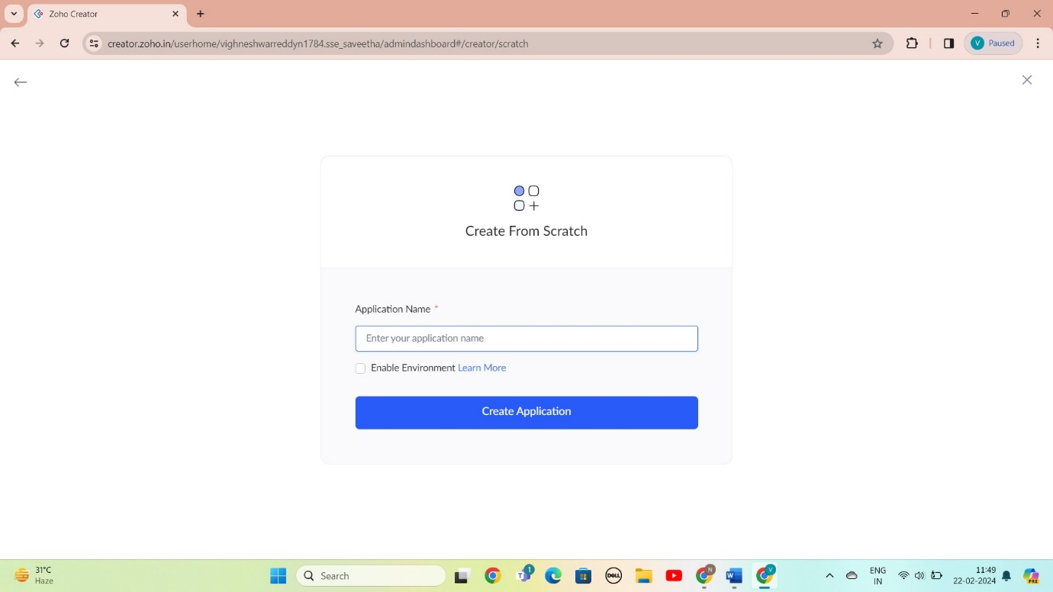

STEP 5: CREATED NEW FORM

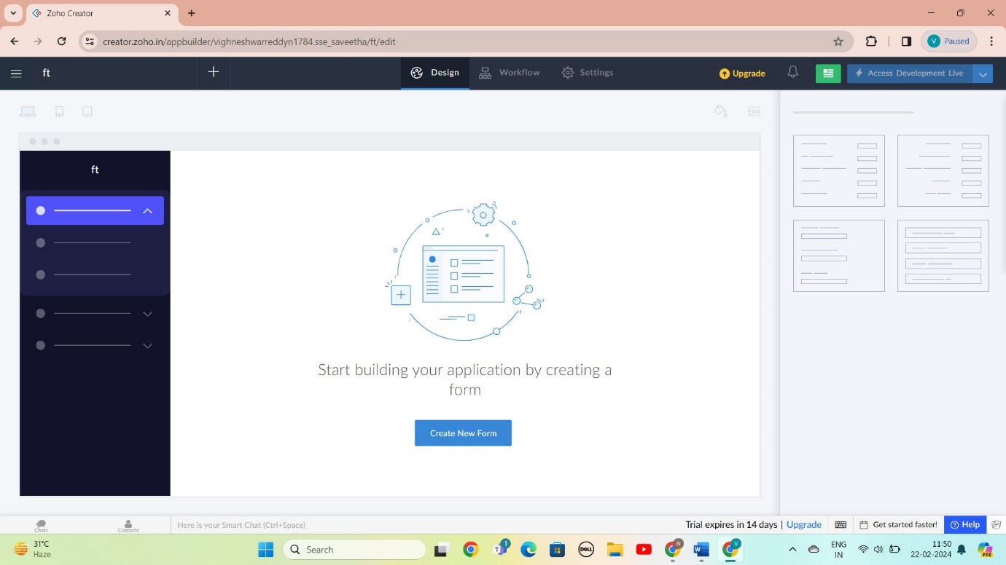

STEP 6: SELECT BASIC FILED FROM GIVEN BELOW AND DEVELOP APPLICATION

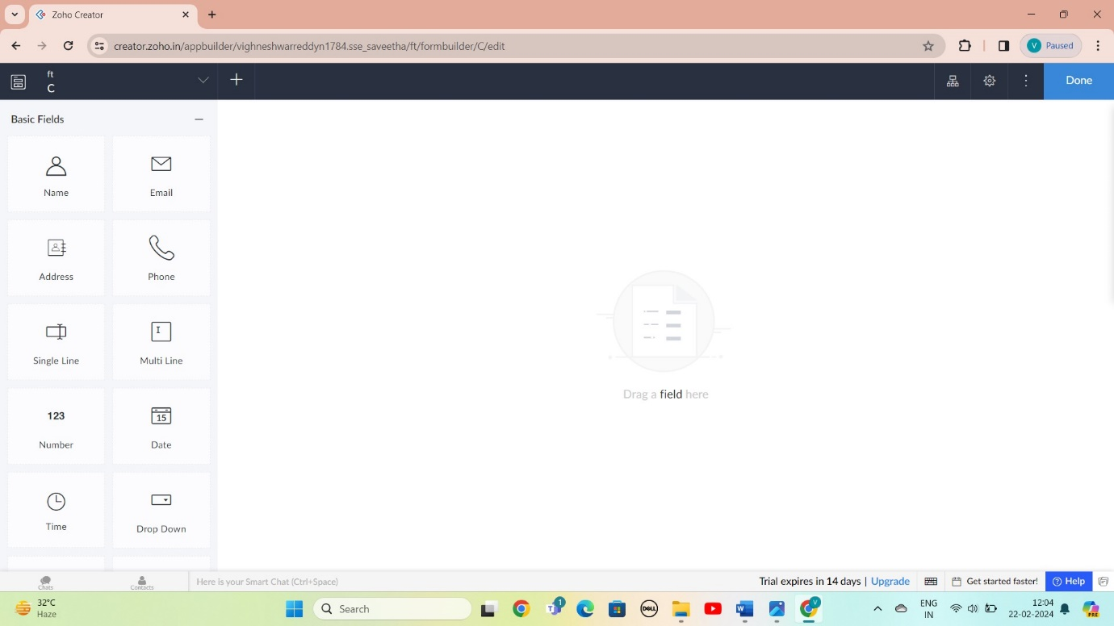

STEP 7: THE SOFTWARE AS BEEN CREATE LOGIN

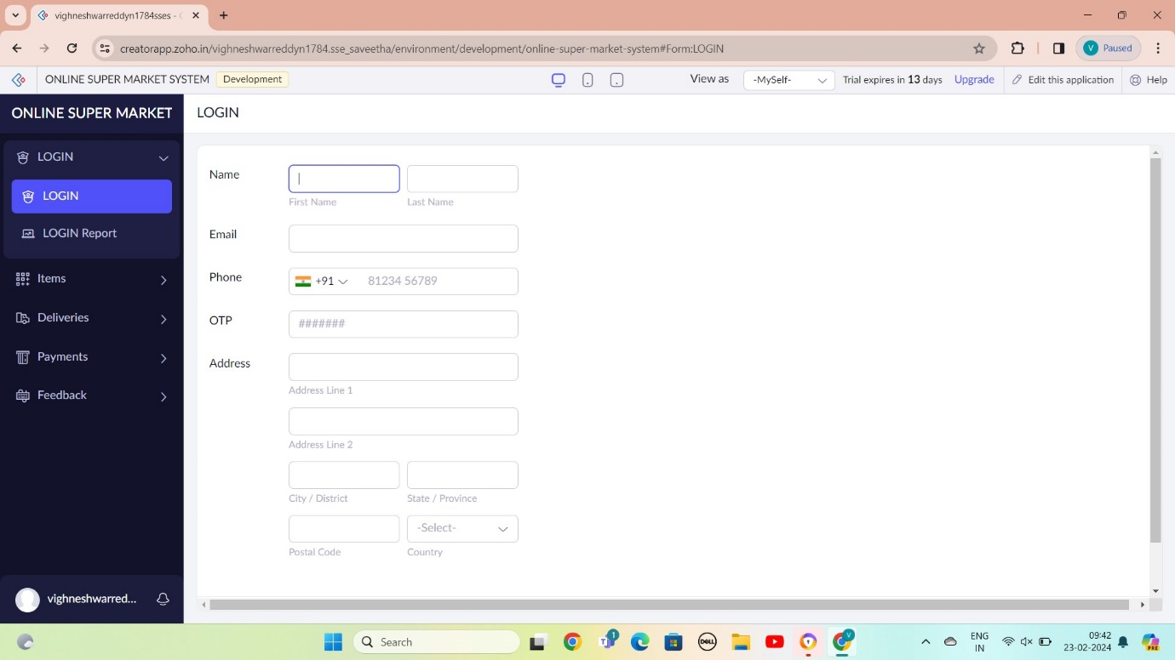

STEP 8: THE SOFTWARE AS BEEN CREATE SLECTING ITEMS

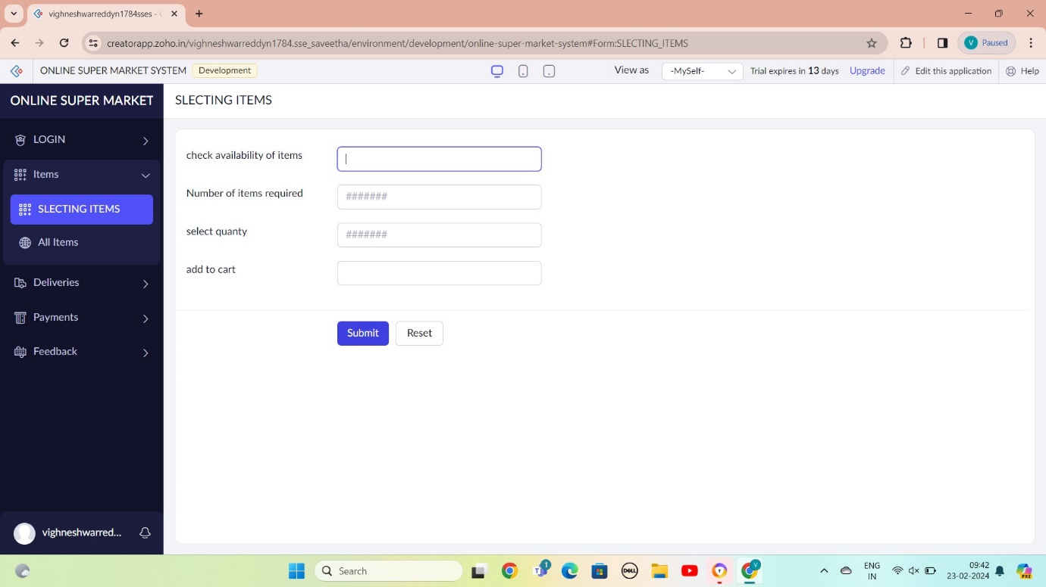

STEP 9: THE SOFTWARE AS BEEN CREATE DELIVERY

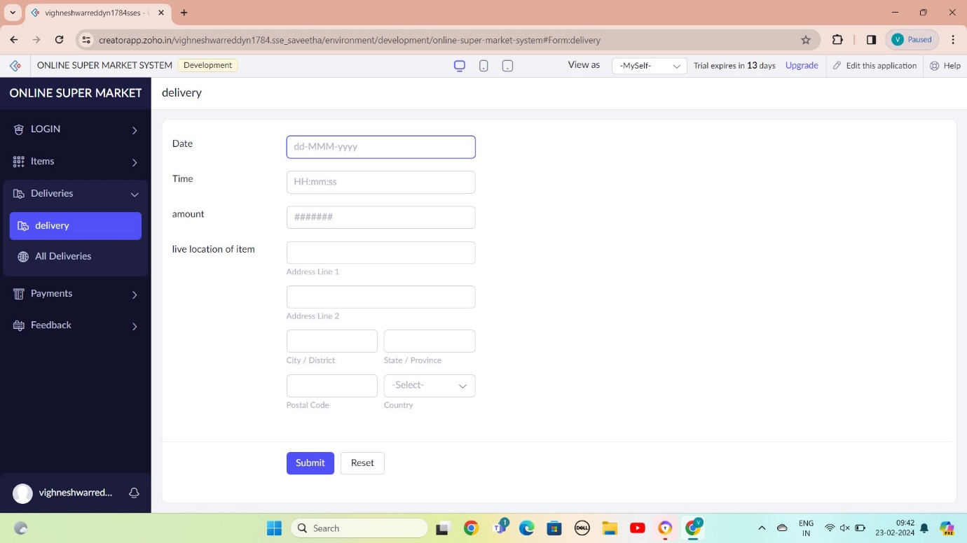

STEP 10: THE SOFTWARE AS BEEN CREATE PAYMENTS

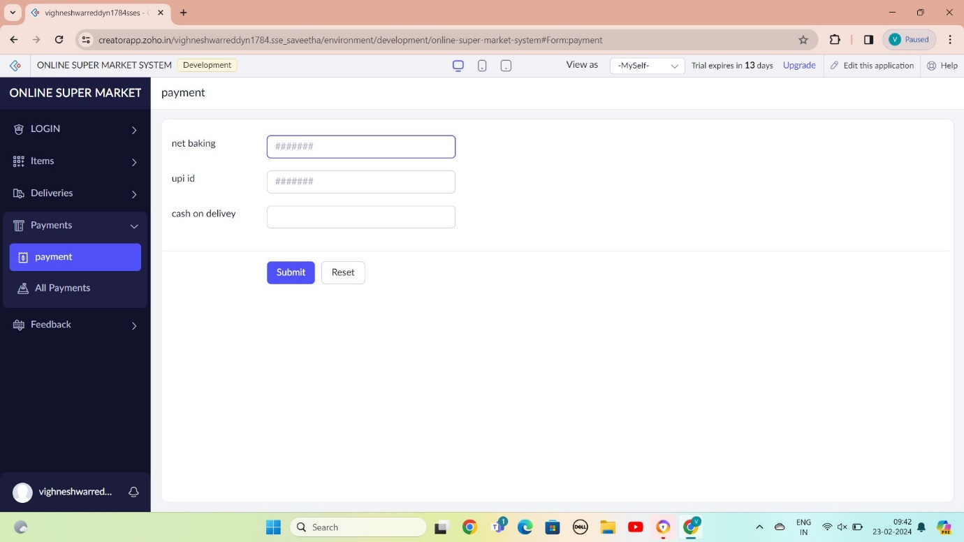

STEP 11: THE SOFTWARE AS CREAT FEEDBACK

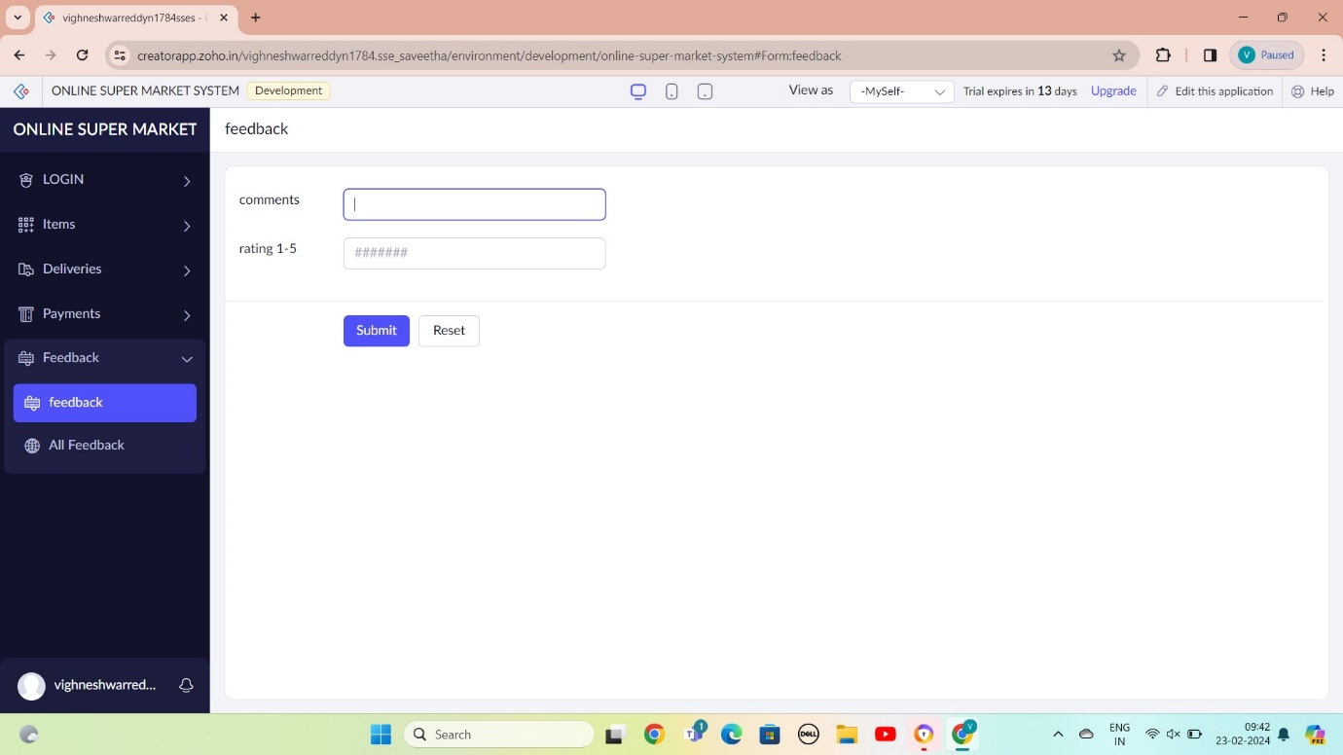

STEP 12: THE SOFTWARE AS BEEN CREATE

